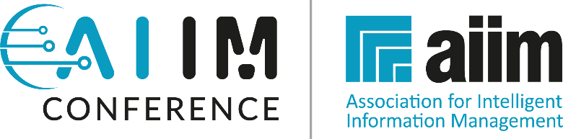

Dear [Insert Your Boss’ Name Here],

I am writing to bring to your attention an exceptional opportunity that could significantly benefit both my professional development and our organization's growth. The AIIM24 Conference, scheduled for April 3-5, 2024, in San Antonio, Texas, is a premier event in the field of information management, featuring an impressive lineup of industry leaders and experts.

Our current focus on [insert specific project or organizational goal] aligns perfectly with the insights and learning opportunities offered at AIIM24. This conference is not just an event; it's a convergence of over 600 information management professionals sharing groundbreaking ideas and practices.

This year's conference is especially noteworthy due to the participation of prominent figures from leading organizations such as Iron Mountain, Microsoft, Shell, OpenText, AvePoint, as well as key representatives from federal agencies like the FBI and the Department of Defense (DoD). Their insights and experiences are invaluable, offering us a chance to learn from the best in the industry

Additionally, the conference includes a pre-conference workshop focused on preparing attendees to sit for the Certified Information Professional (CIP) exam – a qualification that can significantly elevate our team’s expertise and industry standing.

Here’s a detailed cost breakdown for attending AIIM24:

Airfare: [add your costs]
AIIM24 Conference Fee: $1,550 (with a $200 discount for AIIM members)
AIIM Membership: $160 (offering access to the member discount and other resources)
Pre-Conference Training (CIP Exam Prep): $599
Hotel (3 nights at $229/night): $687 (additional night for pre-conference $916)
Total Estimated Cost (without membership discount): [Total of options chosen]
Total Estimated Cost (with membership discount): [Total of options chosen]

Furthermore, there's a compelling opportunity for team development at AIIM24: the conference provides a substantial $400 discount on each ticket for groups of three or more. This significant saving presents an excellent chance for a larger contingent from our team to attend. By doing so, we can amplify the benefits of this experience, fostering broader organizational success and enhancing team learning in a more cohesive and impactful manner.

I firmly believe that attending AIIM24 will not only enrich my professional skills but also bring substantial, actionable benefits to our organization. The chance to interact and learn directly from leaders at Iron Mountain, Microsoft, Shell, OpenText, AvePoint, and specialists from the FBI and DoD, among others, is a rare and valuable opportunity. The insights and knowledge gained from these industry giants can be directly applied to enhance our current projects and strategize future initiatives.

Thank you for considering this investment in our team's growth and our organization’s success. I am eager to discuss how this aligns with our goals and answer any questions you may have. I appreciate your prompt consideration of this request to facilitate timely travel arrangements and take advantage of the group discount opportunity.

Sincerely,

[Insert Your Name Here]

